# **Linux Agent Installation**

**Update the Configurations:**

Update necessary configurations like server URL, time intervals, Log_path in the **`Config.ini** ` file on the given code.

[product key]

Key = “ENTER YOUR PRODUCT KEY”.

Mainly Add the Product key in the config.ini which you generated using Web UI.

navigate to cd **src** and run the command :

**python3 setup.py sdist bdist_wheel** **or python setup.py sdist bdist_wheel.**

**Installation:**

**1.Install User monitor Agent:**

--place the zip folder and unzip it in home location

        Unzip linuxagent.zip

**--** run the script file

**source linux.sh 2>&1 | tee output.log**

note : download the linux.sh form git repository.

**--**To active python virtual env

**source /usr/local/share/usermonitor/.venv/bin/activate**

--Navigate to dist (linuxagent folder)

**cd dist**

- If you want to uninstall a package, use:

**pip uninstall MonitorUser-0.1-py3-none-any.whl**

- Install a package named MonitorUser from a wheel file.

**pip install MonitorUser-0.1-py3-none-any.whl**

**2. Start, Stop, and Check Service Status:**

--Start the service.

**sudo systemctl start usermonitor.service**

--Check the status of the service.

**sudo systemctl status usermonitor.service**

-- Stop the service.

**sudo systemctl stop usermonitor.service**

**3. Enable or Disable Service:**

-- Enable the service to start automatically on boot.

**sudo systemctl enable usermonitor.service**

---Disable the service to prevent it from starting automatically on boot.

**sudo systemctl disable usermonitor.service**

**4. To view log**

**tail -f  /var/log/Usermonitor/<current date>.log**

**Implementation of auto updates in the agent**

**Step 1:**

### **Create the wheel distribution**

Open your command line interface (CLI), navigate to your project directory, and run the following commands:

**‘python setup.py sdist bdist_wheel’**

This command will generate the distribution files, including the **.whl file**, in a **dist** directory within your project directory.

**Step 2:**

Upload your .whl file in the versions of user monitor api server code in Linux folder

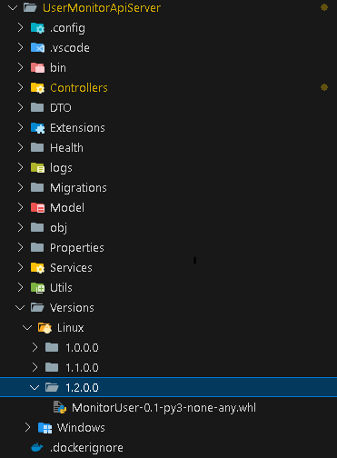

**Step 3 :**

Change the New Version in the **Updater Models** table on Database Manually.

**Step 4:**

Automatically replace the installation files inside virtual env bin directory at midnight 12:00 AM. This task will execute a script that uninstall your existing **MonitorUser-0.1-py3-none-any.whl** into the bin directory and re-install the new .whl file which you have given into the versions folder.